MACHINE LEARNING   
ASSIGNMENT: 1

NAME: Muhammad Arsalan

CMS_ID: 54485

TASK NO 1:

to run the >> conda info command in terminal:

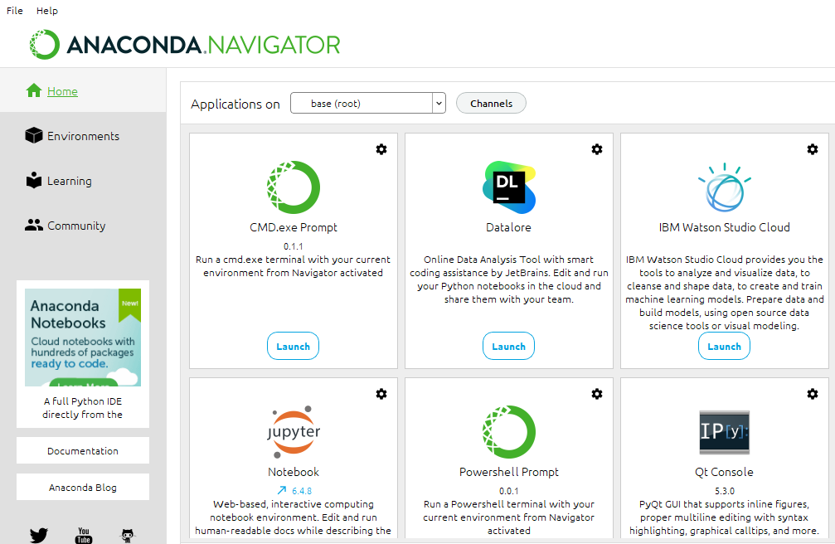

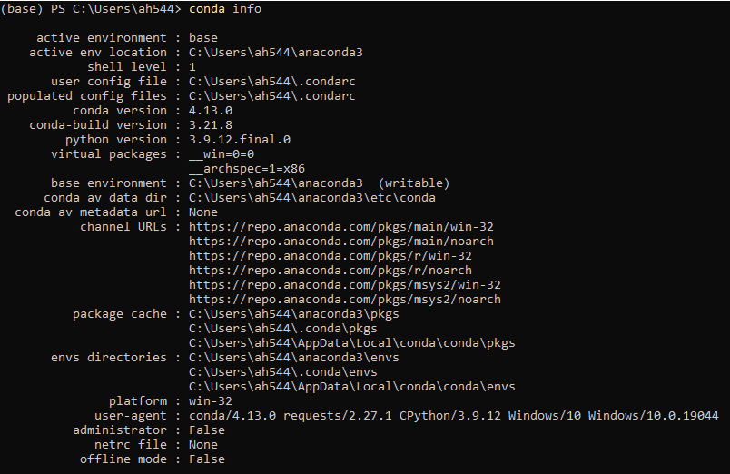

TASK NO 2:

The result of below code:

Import matplotlib .pyplot as plt

Plt.plot ([1,2,3,4,],[1,2,7,14])

Plt.plot ([0, 6, 0,20])

Plt. Show( )

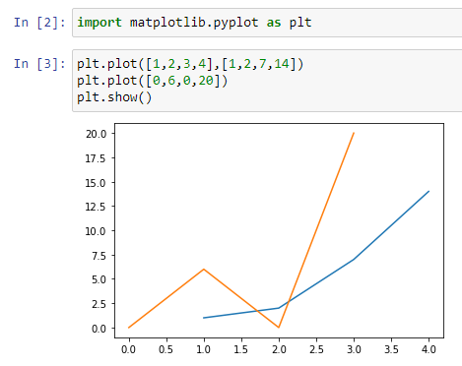

TASK NO 3:

Own choice code result like this :

Import matplotlib .pyplot as plt

Plt.plot ([12,13,4,5,9],[1,2,0,7,23])

Plt.plot ([10, 1, 12,0])

Plt. Show( )

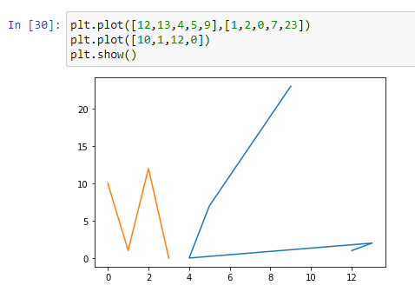

TASK NO 4:

Create a GitHub account:

